STUDENT Joseph Roper

SALFORD CITY COLLEGE | FUTURE SKILLS

BTEC National Extended Diploma in Creative Media Production

UNIT 20: the evolution of gaming hardware

Unit 20 – Task 1

# Arcade

The world's first video game arcade system was released in 1971 named Computer Space. This was a year before the games company Atari well known for arcade cabinets started up. The coin-operated machine played an Asteroids esc game without the meteors and instead was replaced with other shooting space ships. Arcade games were especially popular in the 1990’s with the release of many fighting games such as Street Fighter and Mortal Kombat which struck the globe with highly competitive, addictive and yet fun gameplay.

[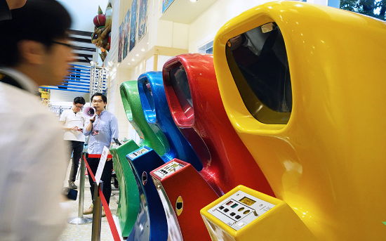](https://www.engadget.com/2014/07/09/worlds-first-arcade-videogame/?guccounter=1)[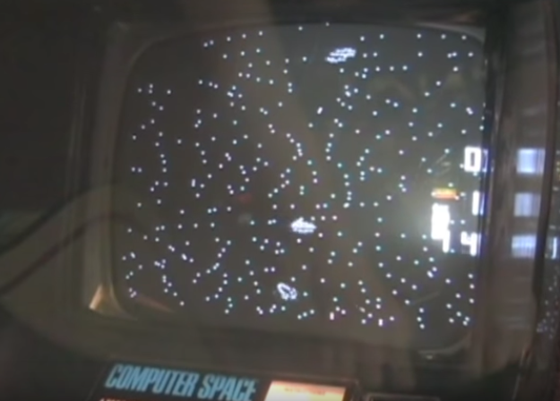](https://www.youtube.com/watch?v=LUv3z7XGRRc)

Arcade machines don’t all have to be video game related as some of the classic arcade machines that are at every game plaza involve interacting with a real life object for example hitting a punching bag as hard as you can and dropping coins on to a larger stack hoping to push them off the ledge and into your pocket. The advantage of having a game that's based on human interactions and not graphics on a screen is that they can never get outdated by advanced technology or that's at least what I believe, as if I was to walk into an arcade now I would still rather play air hockey with my friends than race on my own while staring at a pixelated screen.

[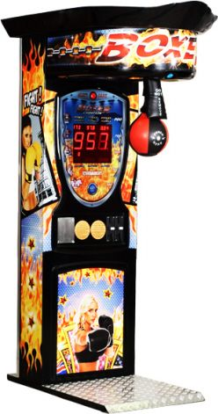](https://www.bmigaming.com/games-sports-boxing.htm)[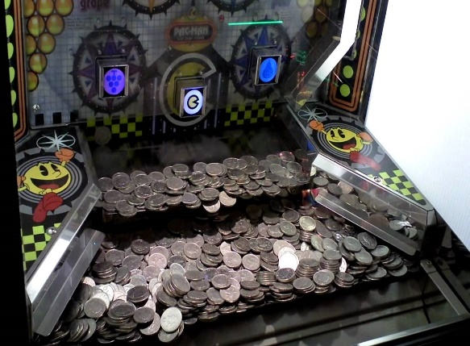](https://www.youtube.com/watch?v=Wd5eYPuknQw)[](https://www.youtube.com/watch?v=zkZ-G_fJi0s)

Currently arcade machines aren't very popular due to the games that were previously exclusive to arcade cabinets now being playable on home consoles due to improved hardware. I think fighting games no longer belong in arcades and instead at home where they are more widely available but I still think arcades should exist with games that require big machines such as Dance Dance Revolution (DDR), air hockey machines and the basketball hoop ones. Cleary arcades aren’t going as they are still prevalent in Japan.

# Console

The first home gaming console was released in the U.S.A in September 1972 named the Magnavox Odyssey. It was developed by a small team for 3 years, the system plays variants of the famous game Pong by having two paddles that hit a ball back and forth, but the Magnavox Odyssey used the sprites displayed in Pong and allowed them to be controlled and moved differently for more game modes. Unlike Pong you can add different plastic film screens onto the players TV to make the game look different to suit the game mode you were playing, these films and games include; table tennis, ski, Simon says, tennis and many more. Compared to Pong the console didn’t sell well only managing to distribute approximately 350,000 units. I believe this system did not sell well as the console didn’t show enough innovative gameplay to convince someone to spend $100 when they could visit a local arcade and spend 25 cent to play roughly the same game.

[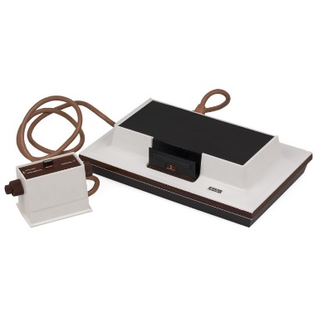](http://www.computinghistory.org.uk/det/16909/Magnavox-Odyssey/)[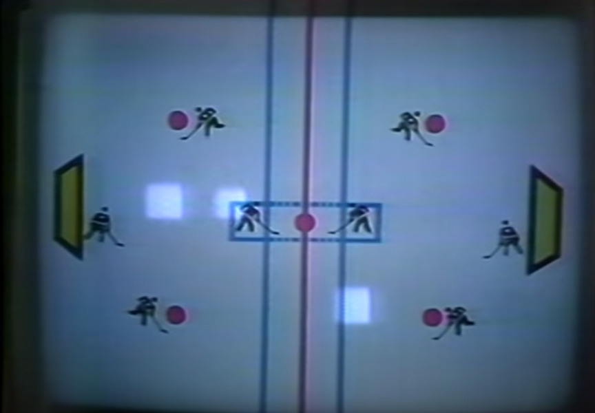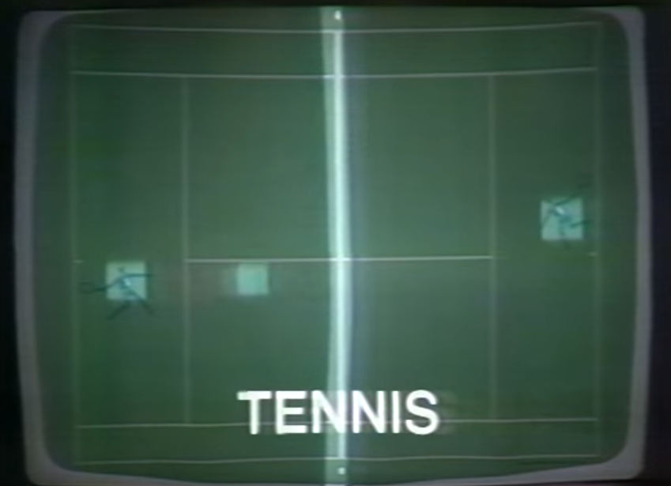](https://www.youtube.com/watch?v=H2EIsnr_cv4)

Consoles now can run phenomenal games with great graphics and gameplay due to the mechanical advances in computing power growing astronomically. Gaming consoles bring in a lot of commercial success now compared to in 1972 when the world wasn’t ready for home gaming. However now you have consoles powerful enough to run Virtual Reality (VR) with the Xbox One Pro using the Oculus Rift and the PS4 Pro using their own VR headset to play cutting edge immersive games.

[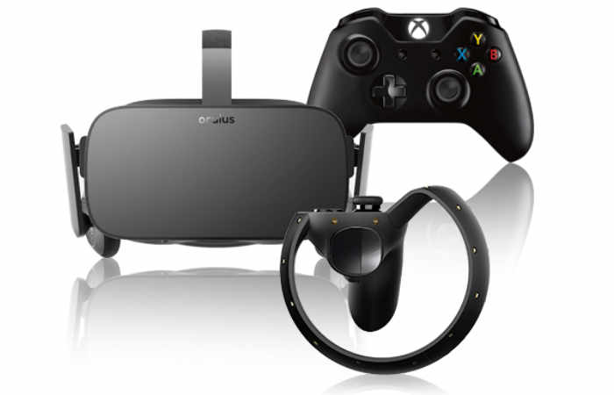](https://www.geeky-gadgets.com/oculus-rift-xbox-one-streaming-support-13-12-2016/)[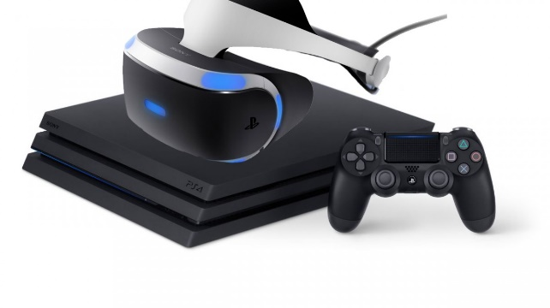](https://wccftech.com/itagaki-ps4-pro-just-rhetoric-vr/)

Currently I think consoles will stay in the gaming market as they have a huge audience who just want to start playing games instantly without the problems many PC players face with security issues and outdated hardware. I believe computers will always be able to have better hardware but I think it’s nothing to boast about as all the games playable on computer can usually run on consoles.

# PC

The first personal computer (PC) to run a game was the PDP-1 which parts filled up an entire room. The computer was able to run the game Spacewar developed in 1962, the game was playable by 2 people who each controlled their own spaceship trying to shoot the other player down. The system didn’t have the best graphics compared to the ultra 4K games of the present, although compared to arcade games such as Pong and Asteroids they hold up.

[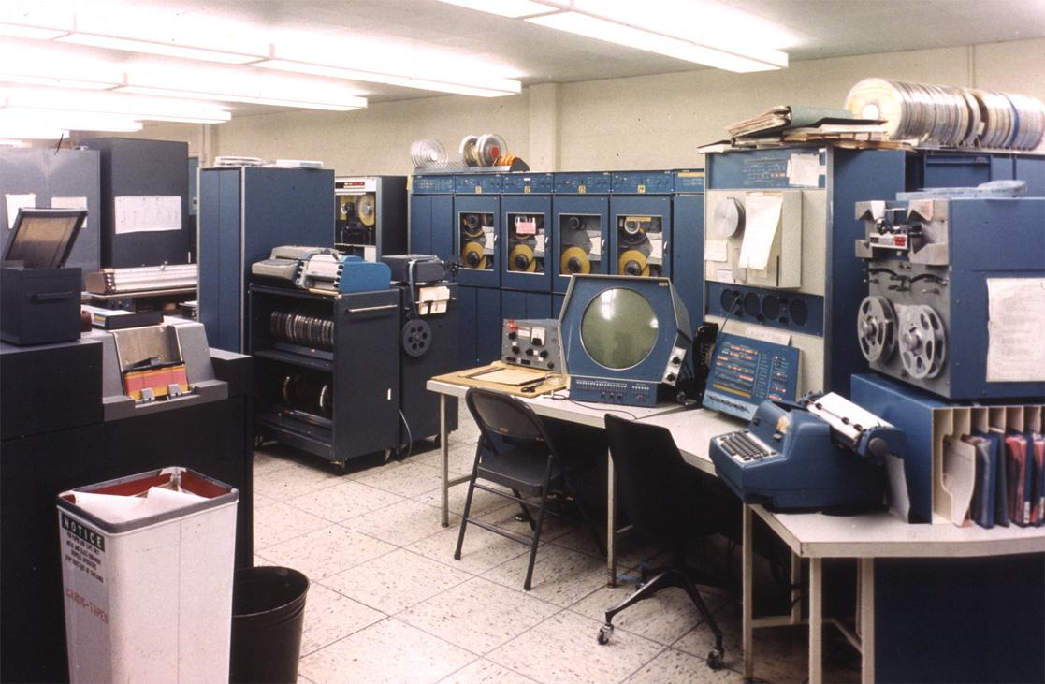](http://www.computer-history.info/Page4.dir/pages/PDP.1.dir/)[](https://www.youtube.com/watch?v=Rmvb4Hktv7U)

Personal computers now can be as small as your hand but the ones used to play high end games are usually bigger, you can also replace your computers parts and upgrade it with readily available parts from the internet and stores. There are many companies now specifically for computers such as Microsoft who want everybody to use their user interface platform Windows so that if someone wants to put software on a computer they would have to contact and most likely pay Microsoft to display it on the Windows online store.

[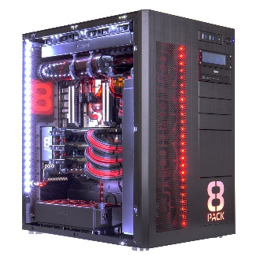](https://www.overclockers.co.uk/8pack-supernova-intel-core-i9-7980xe-4.6ghz-ddr4-extreme-overclocked-pc-fs-001-8p.html) [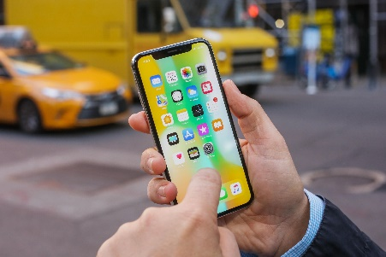](https://www.cnet.com/reviews/apple-iphone-x-review/)

I believe computers will always be used especially personal computers however I think they will decrease in size immensely and still be able to run hardware demanding software and games such as virtual reality.

# Mobile

Although many people believe Snake on the Nokia 6110 to be the very first mobile game it is not. In fact the first mobile game was actually a Tetris clone playable on the Hagenuk MT-2000 which came out 3 years before the Nokia. The Hagenuk MT-2000 may have been innovative but the hardware available at the time only allowed up to one simple game to be stored on the device, other than Tetris the phone didn’t offer much else in terms of quality therefore the system didn’t sell well and many people believed it to be a novelty. Currently phones can now store up to hundreds of high quality games on one device and have millions of games to choose from which can be downloaded, played and deleted at any time.

[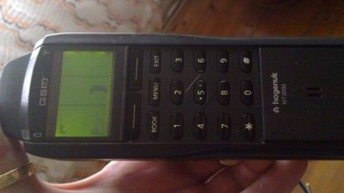](https://www.google.co.uk/url?sa=i&source=images&cd=&ved=2ahUKEwiNs5bN6-_fAhUIyYUKHTHwDMoQjxx6BAgBEAI&url=https://www.phonearena.com/news/This-was-the-worlds-first-cell-phone-with-a-game-loaded-on-it_id62920&psig=AOvVaw1bZw6EdxJv_VpNYhc6UMtJ&ust=1547641320096122) [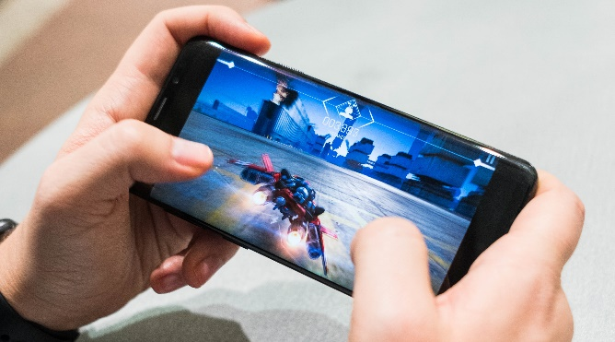](https://www.techradar.com/news/best-phone-for-gaming)

Another form of mobile gaming is with handheld consoles which people believe to be superior over mobile gaming as these machines are built specifically to play games on meaning that they can run more hardware intensive games meaning that the games can look better, be bigger and most likely more fun. Popular handheld consoles are usually produced by the company Nintendo with the Gameboy, DS, 3DS and now the newest console in the line the Nintendo Switch. Handheld games in my opinion will always out rank mobile games as there is just more things you can do with a game on a handheld due to the bigger screens, better hardware and controls. The new Zelda Breath of the Wild a handheld game won game of the year when put against games from computers and home consoles.

[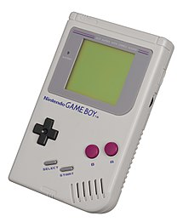](https://en.wikipedia.org/wiki/Game_Boy)[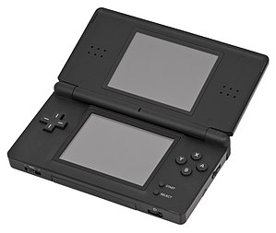](https://en.wikipedia.org/wiki/Nintendo_DS_Lite)[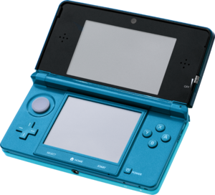](https://en.wikipedia.org/wiki/Nintendo_3DS)[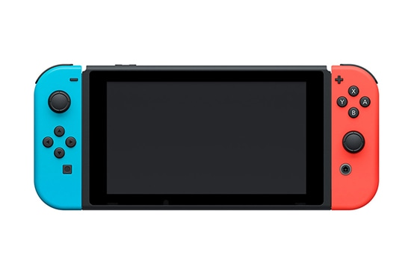](https://www.nintendo.com/en_CA/switch/buy-now/)

Compared, handheld gaming I believe will always be better than mobile gaming even if the latter is more accessible and convenient as everybody owns a phone. Although I don’t think the two should be compared as they are used for different reasons and purposes. Mobile gaming is usually used to waste time while waiting for example while on the bus. Whereas handheld consoles are used more for enjoyment and to play games when at a friend’s house etc. Mobile gaming will always stay, as it is a need for people and will constantly improve along with mobile phones and new hardware for a better gaming experience.

# TV

Plug and play machines were very popular in the 2000’s, they were plastic boxes with a controller on top which you would plug into your TV using a scart lead. The machine would have games stored in the box which would be projected onto the television screen via the scart lead. The games stored on these plug and play machines were usually basic 2D pixelated side scrollers, for example the Spiderman themed machine which held a 2D side scrolling beat em up inside where you would play as Spiderman kicking and punching the famous sinister six.

[](https://www.dkoldies.com/spider-man-plug-and-play-tv-game/)[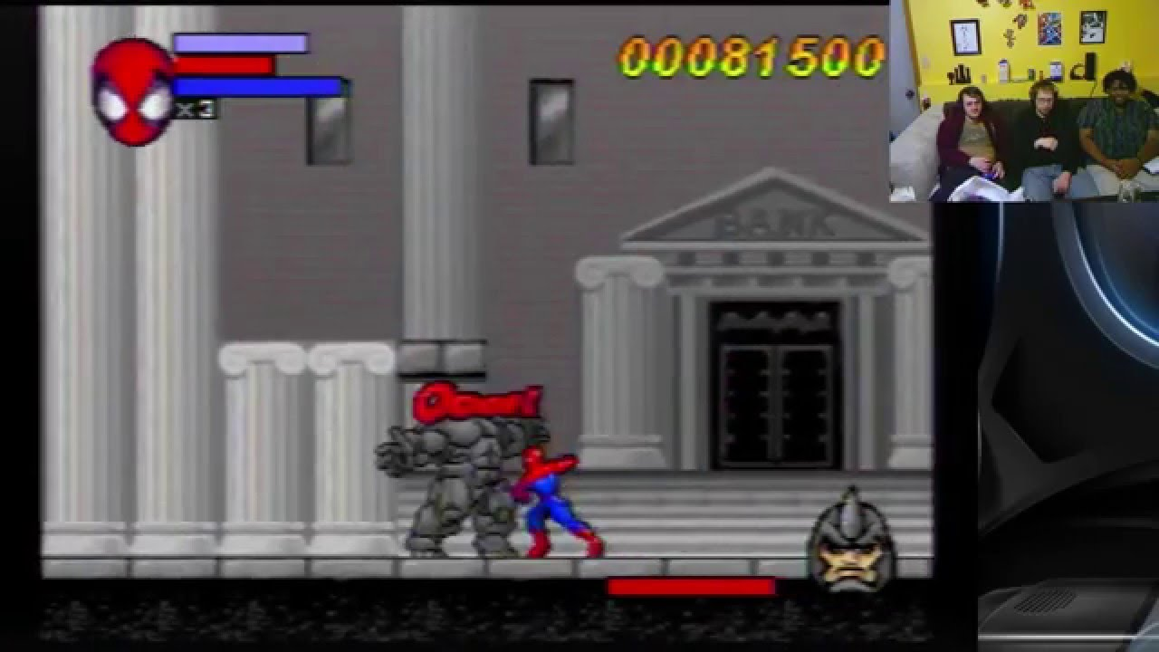](https://www.youtube.com/watch?v=Wh6mqP-A9Gw)

Another form of games on the television came from the red button on your TV remote which would cause a side menu to pop up on your television screen, depending on the channel your TV was on you would be able to play games straight from your TV just like the plug and play games but without the exterior hardware, you would play the games with your TV remote and could even by better games using your TV. The red button was first introduced by the BBC as a way to check things such as lottery scores and extra information about the program you were watching. The BBC started allowing children’s games to be played with the red button in the day time. I believe the best form of the red button was with the partnership between Sky TV and Cartoon Network which allowed you to play the games from Cartoon Network’s website on your television.

[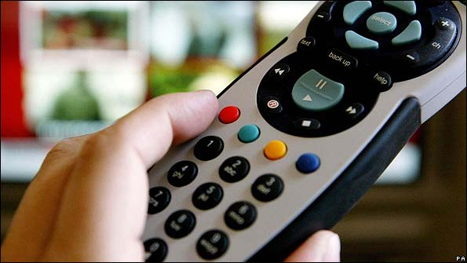](http://www.bbc.co.uk/blogs/sporteditors/2009/10/changes_to_bbc_sport_output_on.html)[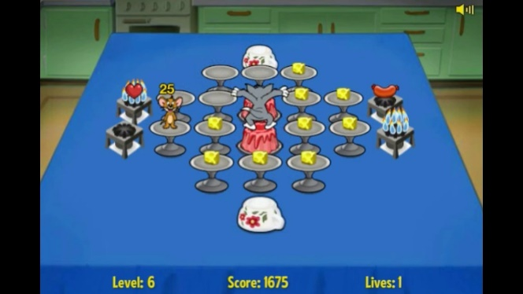](https://www.youtube.com/watch?v=fcakQ6fVRwA)

I believe TV games had their place in the 2000’s as they brought entertainment to the living room for people who couldn’t afford the expensive consoles. However currently some gaming consoles are now quite inexpensive for example the 3DS which you can buy preowned for £60 which hold far superior games compared to those on the TV.

[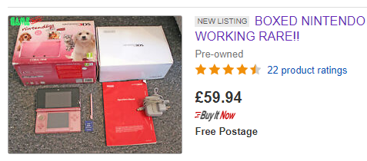](https://www.ebay.co.uk/sch/i.html?_from=R40&_trksid=p2380057.m570.l1313.TR12.TRC2.A0.H0.X3ds.TRS0&_nkw=3ds&_sacat=0)